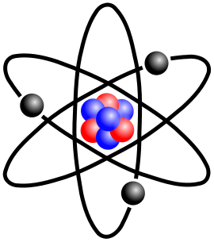
Label (by creating a key) the atom and identify the name of the atom present in the picture.

The Atomic Hypothesis
- What does the word atom mean?

- Aristotle taught that all matter is composed of various combinations of four elements ______.

- What is Brownian motion?

- If all scientific knowledge were to be lost/destroyed what one sentence would Richard Feynman leave for future generations?

Characteristics of Atoms
- Explain what is meant by the following statements:
  - Atoms are incredibly tiny

  - Atoms are numerous

  - Atoms get around

  - Atoms are ageless

Atomic Imagery
- Atoms are smaller than the __________________ of visible _______________.
- Why was 1970 a historic year for our understanding of what an atom looks like?

- Describe or Draw a picture of one of the models of the atom.

- Why is no model of the atom truly correct?

Atomic Structure
- Where is the majority of the mass of an atom concentrated?

- What happens when the nuclei of two or more atoms are squashed together?

- Define a nucleon. How is a nucleon related to a proton and a neutron?

- Why do atoms combine to form molecules?

The Elements
- Define the term element.

- How were heavier elements created?

- What five elements are living things primarily composed of?

The Periodic Table of the Elements
- How is the periodic table of elements organized?

Isotopes
- What is an isotope?

- What is the atomic mass?

- Where does the number we see on periodic table (in terms of mass) come from?

Compounds and Mixtures
- How is a compound different than a mixture?

Molecules
- What is a molecule? Draw a picture of a molecule.

- What is required to pull apart molecules?

Antimatter
- What is antimatter composed of? Make sure to make reference to the types of charges each portion of antimatter has.

- How were positrons first discovered?

- How can we produce antiparticles today?

- Why can’t antimatter and matter be in our immediate environment?

Dark Matter
- What is dark matter?

Higgs-Boson Critical Thinking
- Why do we care about finding this particle called the Higgs-Boson?

