Fireworks Webquest Name_______________ Class_________
Part I. Answer the following questions by searching the given websites or finding your own websites.
http://news.bbc.co.uk/cbbcnews/hi/newsid_4360000/newsid_4361500/4361562.stm
*link will not work at LSHS, try it at home*http://www.fireworks.com/safety/fireworks-history.asp
http://www.howstuffworks.com/fireworks1.htm
*link will not work at LSHS, try it at home*http://cc.oulu.fi/~kempmp/colours.html
http://www.glencoe.com/sec/science/webquest/content/fireworks2.shtml
http://www.science-search.org/index/Technology/Pyrotechnics/Fireworks/
http://www.teachersdomain.org (use kgassergroup as the login and password)
http://www.pbs.org/wgbh/nova/kaboom/anatomy.html
http://library.thinkquest.org/15384/chem/
http://www.ch.ic.ac.uk/local/projects/gondhia/composition.html
http://www.fireworkstheory.net/color.html

- What exactly is a firework?

- Where and when were the first fireworks invented?

- Who were the first Europeans to master fireworks?

- What type of simple chemical reaction occurs in fireworks?

- What are the components of black powder?

- What types of elements are responsible for the colors of fireworks?

- What is responsible for the whistling sound that often accompanies fireworks?

- Fill in the table that lists the chemical compounds that create the following colors.
(You may use chemical formulas rather than common names of compounds in your table.)
Blue
Turquoise
Yellow
Pink
Brilliant red
Green
Purple
White

Part II:
On the Internet, find http://www.pbs.org/wgbh/nova/kaboom/elemental/. From the periodic table on that site, identify which of the clickable elements belong in each of the categories below and their use in fireworks.
Family | Element Name | Use in fireworks
Alkali metals
Alkaline earth metals
Boron family
Carbon family
Nitrogen family
Oxygen family
Halogen family
Transition metals
Metalloids
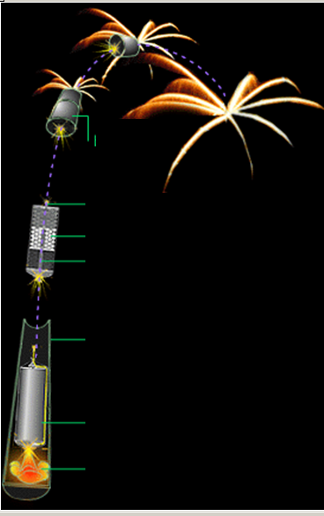
E. Click Kaboom to go to a site devoted to fireworks chemistry. Check out the links to find the diagram of parts of a firework. Label the 7 important parts on the diagram below.

Assessment (to be done on a separate paper):
- From the PBS site, choose elements that you would use in making your own firework. You need to include an element for lift, 4 elements for color, and one element for sparkles. Explain why you chose each one. Give your answer in complete sentences.
- Explain the role of electrons in the production of colored light. In order to be scored, your answer must be in a paragraph using complete sentences. The terms energy level, ground state, excited state, wavelength, and photon must appear in the paragraph.

