Unit 1 - An Introduction to Chemistry 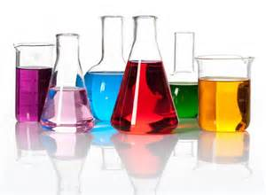

 | September 6th, 2016  First day of school  ½ Day  -Introduction to classroom policies, rules and expectations (day 2 maybe)  -Student fill out information about themselves | September 7th, 2016  -Lab: How to make a sandwich → based on student designs  -Detailed instructions and step by step guidance of how to write a lab report (what to include, etc.)  -Students vote on who had the best one  -Go over lab write-up @ the end | September 8th, 2016  Picture Day  -Get organized today!  -Need. Construction paper, masking tape, markers  -HW: Graphing wkst  -Remind students to bring their ID’s to check textbooks out of the library on Friday | September 9th, 2016  -What is chemistry? Why is it important?  -A story of two substances  -Analyzing data (Matter & Change p.21)  -Check textbooks out of the library today (grab from the cart in library)
September 12th, 2016  -White board warm-up activity  -Notes: Metric System  -HW: Metric System Packet  -Notes: Scientific Notation  -HW: Scientific Notation wkst (??) → Need 2 days??? | September 13th, 2016  In Room 126 Today  -Notes: Lab Safety  -Demo: Baking Soda & CaCl₂  - | September 14th, 2016  Early Release  -Notes: Measuring things  -POGIL: Measurement | September 15th, 2016  -Notes: Physical & Chemical Changes, Chemical Reactions, (brief) solutions/mixtures | September 16th, 2016  -Notes: Temperature  -Video?  -HW: Temperature Calculations wkst
September 19th, 2016  -Design an investigation about the transfer of thermal energy | September 20th, 2016  -Conference about 9/19 design | September 21st, 2016  -Review for test | September 22nd, 2016  In Room 126 Today  -Conduct your Lab | September 23rd, 2016  -Unit 1 Test

