- Date: ___________ Question: What are Chlorofluorocarbons? Roughly when were they inverted and for what purpose? What is the environmental impact of this compound?

- Date: ___________ Question: Using the items on your desk, describe them in terms of qualitative and quantitate data.

- Date: ___________ Question: What is the difference between mass and weight?

- Date: ___________ Question: Answer the following questions from the Data Analysis lab on p.21
1. Describe the trend in the data for 1979-2008.  - The minimum ozone declines from 250 DU in January to around 220 DU. From March until mid-July, the median increases slightly.  - The minimum ozone increases from 150 DU in January to around 220 DU. From March until mid-July, the median increases slightly.  - From July to October there is a steep decrease which is followed by an increase from October to December.  - A and C  - B and C | 3. Identify the month during which the ozone levels were the lowest in 1979-2008. 2009?  - January/February  - September/October  - March/April  - June/July
2. Evaluate how the 2009 data compare with the data from 1979-2008.  - The 2009 data shows a sharp departure from the 1979-2008 data.  - The 2009 data follows the same trend as the 1979-2008 data.  - A and B  - None of the above | 4. Do these data points reflect any about temperature and about ozone depletion?  - The ozone levels were at their lowest during the coldest months of the year (January and February).  - The ozone levels were at their lowest during the spring months (March and April).  - The ozone levels were at their lowest during the fall months (September and October).  - The ozone levels were at their lowest during the summer months (June and July).

- Date: ___________ Question: Answer question #49 on p. 27 (a and b)

- Date: ___________ Question: Answer the DBQ on p. 27
1. In what year did the largest maximum area of ozone occur?  - 2003  - 1998  - 2000  - 2006 | 3. What is the average maximum area of ozone hole between the years of 2005 and 2009?  - 23.7 million  - 23.4 million  - 25.0 million  - 27.3 million
2. In what year did the smallest maximum area of ozone occur?  - 1995  - 1996  - 2002  - 2004 | 4. During which period of time was the average maximum area of ozone the largest?  - 2000-2004  - 2005-2008  - 1995-1998  - 1998-2000

- Date: ___________ Question: Complete the SAT Subject Test on p. 29
14.
15.
16.
17.
18.
19.
- Date: ___________ Question: On this graph identify the independent and dependent variables.
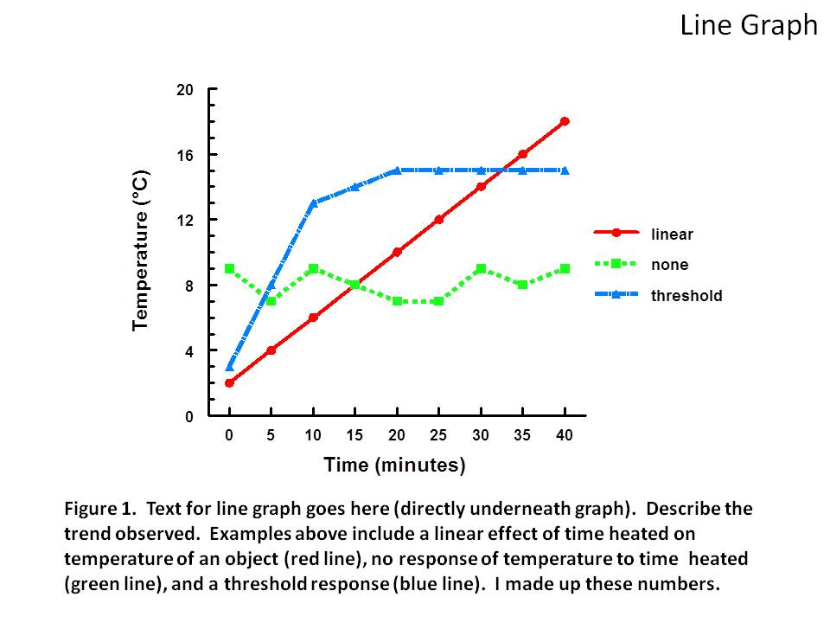
- Date: ___________ Question: What is the difference between a precise and an accurate measurement?

#10. Date: ___________ Question: Why do we use significant figures?

#11. Date: ___________ Question: Plot two lines on the graph below, one with a positive slope and one with a negative slope. For each line, explain what happens to the dependent variable when the independent variable increases.

#12. Date: ___________ Question: Answer question #98 on p. 63

#13. Date: ___________ Question: Answer question #111 on p. 64

#14. Date: ___________ Question: Answer the DBQ question on p. 65
128. How is temperature related to the density of ocean water at depths less than 1000m?  - The temperature is fairly consistent with a consistent density throughout the entire ocean.  - As the temperature decreases, the density of the ocean increases.  - As the temperature increases, the density of the ocean decreases.  - There is no relationship between temperature and density. | 130. Describe how salinity change as the ocean water cools.  - As the ocean water increases above 1000m the salinity increases.  - As the ocean water increases above 500m the salinity increases  - As the ocean water cools below 1000m the salinity increases.  - As the ocean water cools below 500m the salinity increases.
129. Describe the effect of depth on salinity.
- The salinity increases with depth
- The salinity remains constant with depth
- The salinity decreases with depth
- The salinity levels are unchanged by the depth

