Date: _______________ BW Question: __________________________________________________

Date: _______________ BW Question: __________________________________________________

Date: _______________ BW Question: __________________________________________________

Date: _______________ BW Question: __________________________________________________

Date: _______________ BW Question: __________________________________________________

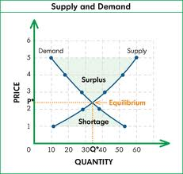

Date: _______________ BW Question: __________________________________________________

