History of the Periodic Table
- Antoine Lavoisier
  - 1700’s
  - French scientist
  - Compiled a list of all elements that were known at the time.
    - Contained 33 elements, that were organized into 4 categories

- John Newland
  - 1864
  - English chemist
  - Arranged elements by increasing atomic mass
  - Noticed the repetition of properties every 8th element
  - Created the law of octaves (after the musical octave in which notes repeat every 8th tone). He showed that the properties of elements repeat in a periodic way.

- Lothar Meyer
  - 1869
  - German chemist Worked with Mendeleev
  - Demonstrated a connection between atomic mass and elements’ properties.
  - Arranged the elements in order of increasing atomic mass.

- Dmitri Mendeleev
  - 1869
  - Russian chemist Worked with Meyer
  - Demonstrated a connection between atomic mass and elements’ properties
  - Arranged the elements in order of increasing atomic mass.
  - Predicted the existence and properties of undiscovered elements.

- Henry Moseley
  - 1913
  - English chemist
  - Discovered that atoms contain a unique number of protons called the atomic number.
  - Arranged elements in order of increasing atomic number, which resulted in a periodic pattern of properties.

Periodic Law – States that when the elements are arranged by increasing atomic number, there is a periodic repetition of their properties.

Groups – A vertical column of elements in the periodic table arranged in order of increasing atomic number.
- Also called a family

Periods – A horizontal row of elements in the modern periodic table

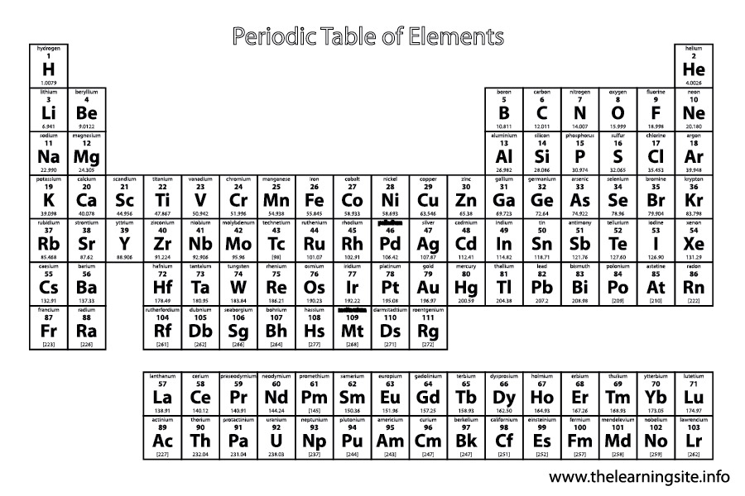

Representative Elements – Elements from group 1, 2, and 13-18 in the modern periodic table, possessing a wide range of chemical and physical properties.
Transition Elements – Elements in groups 3-12 of the modern periodic table and are further divided into transition metals and inner transition metals.
Alkali Metals – Group 1 elements, except for hydrogen, they are reactive and usually exist as compounds with other elements.
Alkaline Earth Metals – Group2 elements in the modern periodic table and are highly reactive.
Transition Metals – An elements in groups 3-12 that is contained in the d-block of the periodic table and, with some exceptions, is characterized by a filled outermost s orbital of energy level n, and filled or partially filled d orbitals or energy level n-1.
Inner Transition Metals – A type of group B element that is contained in the f-block of the periodic table and is characterized by a filled outermost orbital, and filled or partially filled 4f and 5f orbitals.
- Lanthanide Series – In the periodic table, the f-block elements from period 6 that follow the element lanthanum.
- Actinide Series – In the periodic table, the f-block elements from period 7 that follow the element actinium.
Halogens – A highly reactive group 17 element.
Noble Gases – An extremely unreactive group 18 element.
Metals
Metalloids – An element that has physical and chemical properties of both metals and nonmetals.
Nonmetals
Valence Electrons On the Periodic Table
Alkali Metals
Alkaline Earth Metals
Transition Metals
Group 13
Group 14
Group 15
Group 16
Halogens
Noble Gases

Periodic Table Trends
Atomic Radius – The size of the atom
Trend
Ion – An atom or a bonded group of atoms that has a positive or negative charge.
- Cation
  - A positively charged ion
    - It’s positive because it has lost an electron. So the positively charged protons now outnumber the negatively charged electrons, giving the ion a positive charge.
  - Smaller in size than the original atom
- Anion
  - A negatively charged ion
    - It’s negative because it has gained an electron. So the negatively charged electrons now outnumber the positively charged protons, giving the ion a negative charge.
  - Larger in size than the original atom

Element Charges (Oxidation Number)
Alkali Metals
Alkaline Earth Metals
Transition Metals
Group 13
Group 14
Group 15
Group 16
Halogens
Noble Gases
Ionization Energy – The energy required to remove an electron from a gaseous atom.
- Think of ionization energy as an indication of how strongly an atom’s nucleus holds on to its electrons.
- A high ionization energy indicates the atom has a strong hold on its electrons & vice versa.
Trend
The Octet Rule – States that atoms tend to gain, lose, or share electrons in order to acquire full set of eight valence electrons.
- Example: Sodium Atom vs. Sodium Ion

Electronegativity – The electronegativity of an element indicates the relative ability of its atoms to attract electrons in a chemical bond.
- Values are on p.194
- Trend (Below).

